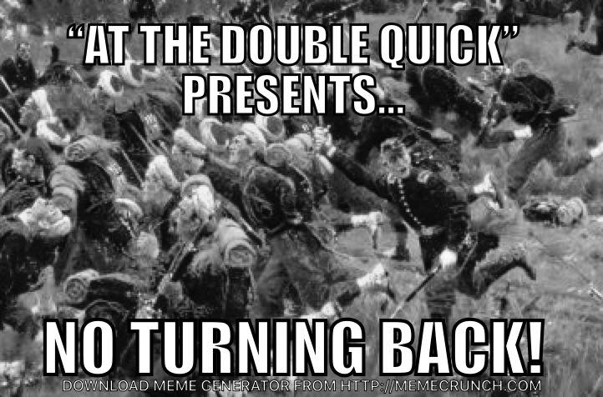
At the Double Quick Civil War Events
“No Turning Back!”
May 4-5, 2019
Reenactment Registration
Warminster Community Park
300 Veterans Way Warminster, PA 18974

The Non- Profit incorporation includes:
The 28th Regiment Co. C, Pennsylvania Volunteer Infantry, The Millbrook Society.

The event will be held on the grounds Warminster Community Park, Warminster, Pennsylvania. The park is conveniently located near both Interstate 95 and the Pennsylvania Turnpike. The park is located on the former site of the Johnsville Naval Air Station and was once a site of early training for NASA and the Apollo missions. Nearby sites of interest to military historians include Civil War campsites, hospitals, memorials and military gravesites and Fort Mifflin.

The event will feature an ambitious historical military program that include the recreation of Union and Confederate military camps along with civilian camps, two public battles and a re-enactor only goal oriented tactical event on Saturday evening.

All regulations including the following will be enforced by Warminster Township

1) No domestic animals i.e. cats, dogs etc. are allowed in military, civilian camps or
left in vehicles.
2) No modern camping allowed i.e. no RVs or campers by re-enactors.
3) No illegal parking, park in only approved areas.
4) No drunken or boisterous behavior as alcohol is prohibited within the park.

Regulation Reminders

1) All units are responsible for policing their areas and depositing trash and other waste
into dumpsters located near the incoming registration area prior to leaving the event.
Straw and leftover wood should be piled at the end of the company street.
2) Remember that at the request of the Park, Federal parking has moved to the parking
area adjacent to the spectator area by the main battlefield. A map or guidance will be
provided to this area.
3) No RV or Camper parking is available, only sutlers will be allowed and must park
where designated. Those with medical issues will be handled on an individual basis.
4) Parking Passes will be required to be displayed in the windshield, only unit affiliation
is required.
5) Picket Passes/wristbands should be issued at time of registration and must be
carried/ worn at all times. These passes may be checked at any given time when
asked by either park personnel or event staff. Failure to do the above could result in
being denied participation in the event.

All event rules and regulation including uniform and civilian dress will be strictly enforced
by event staff. Uniform and civilian dress guidelines are available at www.28thpvi.net

Questions may be directed to:
John Green jjg28thpvi@gmail.com 215-815-0660
Chuck Gilson Cdgilson5@comcast.net, 215-443-8065 (h) or at 276-968-4809 ©

Registration Information
**This year all registrations will be sent to one person.**
**See Fee Information page for Registration Fee, Bounties and Mailing dates.**

A bounty is being paid for artillery pieces pre registered - Artillery is limited to full scale (57”wheels, #1 or#2 field carriages) Commercial reproduction or original tubes in good shape are permissible. Tubes (e.g. 10 lb. Parrots, 3 in. Ordinance, 12 lbs. Napoleon or 12 lbs. or 6 lbs. Field Howitzer) all must be of the correct bore diameter for the type of tube being used. Other period correct field artillery pieces may be considered at the discretion of the event staff. Limbers are strongly urged over ammunition chests and for safety reasons – No homemade, scale down guns, mortars, mountain howitzers, or any other small artillery pieces are not permitted.
Registration is limited to (3) guns per side

VERY IMPORTANT
*****************Specialty Impressions*****************

Specialty impressions require clearance by At the Double -Quick Staff. Please
contact John Green jjg28thpvi@gmail.com Specialty impressions include medical,
spiritual etc. and must be of the period.

Important to Unit Commanders:

Please fill out the unit roster and send it along with the registration form and fees.
Include your Unit / Regiment Number on the registration form.
Completed Infantry, Cavalry, Specialty Impressions and Artillery Registration forms and fees to:
Checks should be made out to the 28th PA Historical Association.

ALL UNITS ATTENDING MUST PROVIDE A COPY/ PROOF OF UNIT INSURANCE!!

Registration fee is $15.00 if post marked by 03/29/2019.

Registrations fee after 03/30/2019 is $20.00.

Walk-on fee is $20.00. Walk-ons are welcome until 11:00 am on Saturday

Children 12yrs and under are free.

Forces will be capped at 300 Federal and 250 Confederates!!!!

Please mail all registrations to:

Chris Harris
400 Colonial Lane
West Deptford, NJ 08096
856-848-5248
c.harris11@verizon.net

Living History & Battle Re-enactment/ Military Registration Form
May 4-5, 2019

Contact Person: ______________________________________________

Contacts Address _______________________________________

City _____________________ State ______ Zip Code__________

Telephone ____________________ Cell ____________________

E-mail Address ________________________________________

Confederate – Battalion Affiliation

1st Legion PACS / 1st Battalion A.N.V. / 1st Confederate Battalion / Longstreet’s Corp / Jackson’s Division / Stonewall Brigade / 5th Battalion A.N.V. / 1st V.R. / Confederate Military

Force / Other __________________________________

Regimental Unit # _____________________

Number of Participants: Military______ Civilian______ Children______

Branch of Service (circle one): Infantry - Artillery

Type of gun (artillery only) ______

Union – Battalion Affiliation

Mifflin Guard / U.S.V / Irish Volunteers / U.S. Reserves/ 2nd Federal Rifles

Other __________________________________

Regimental Unit # ________________________

Number of Participants: Military______ Civilian______ Children_____

Branch of Service (circle one): Infantry - Artillery -

Type of Gun (artillery only) _____

NOTE

Our Registration are used for Park fees, mailing fees, portable toilets, dumpsters, site restoration, insurance (etc.) along with other services related to the event.

Straw is available for a nominal fee near the registration area.

All surplus funds go directly to historic preservation efforts.

Battlefield combatants must be a minimum of 16 years of age or older in order to carry a weapon, those who are Guide ons or functional musicians must be 13 years of age (carrying no weapons) as per liaison committee agreements. Children of all ages are welcome to participate in all civilian activities. Parents or legal guardians are responsible for children
under the age of 18 during the event.

All participants by registering for and/or attending this event, agree that any
sponsoring organization, unit, agents or employees thereof will not be held liable or
responsible for any loss, damage, or injury to persons or property during this event. All
participants further agree to obey the orders of all Superior Officers, Event Staff and
DCNR personnel and to adhere to the rules and regulations of the event. Any violation of
these orders, rules or regulations will result in exclusion from the event, ejection from
the park and may result in arrest. No officers above the rank of Captain (within a
company) without the approval of the event organizers. By registering on this form the
participants agrees to all event stipulations

Signature of Unit Commander _________________________________________

This waiver of Liability must be signed prior to Registration Company Muster Roll
(copy as needed) Rank / Name

1 ________________________________________________________

2 ________________________________________________________

3 ________________________________________________________

4 ________________________________________________________

5 ________________________________________________________

6 ________________________________________________________

7 ________________________________________________________

8 ________________________________________________________

9 ________________________________________________________

10 _______________________________________________________

11 _______________________________________________________

12 _______________________________________________________

13 _______________________________________________________

14 _______________________________________________________

15 _______________________________________________________

16 _______________________________________________________

17 _______________________________________________________

18 _______________________________________________________

19 _______________________________________________________

20 _______________________________________________________

