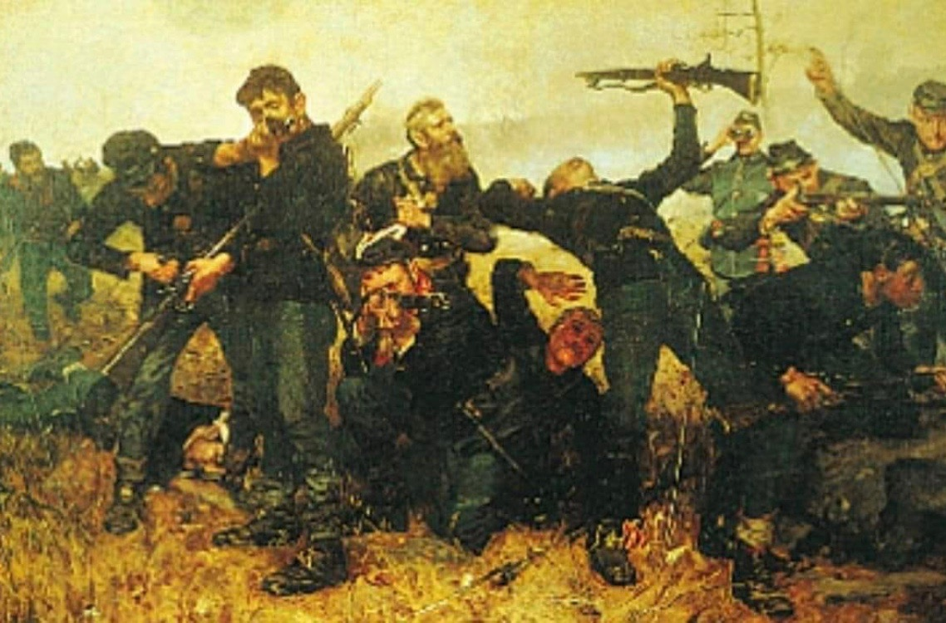

“At the Double Quick Events” presents

No Turning Back!

Battle of the Wilderness
May 4-5, 2019
Warminster Community Park, Warminster PA
300 Veterans Way Warminster, PA 18974
**Special Event Entrance 350 East Bristol Road Warminster, PA 18974**

Additional Information can be found at www.28thpvi.net and At the Double Quick! on Facebook! Any questions, please contact John Green jjg28thpvi@gmail.com or Evan Hosbach ejhosbach@comcast.net.

The Public is invited FREE OF CHARGE! Saturday(9am- 5pm) and Sunday (9am- 3pm) Spectator Battles are planned each day ay 1pm! Come take a walk through history in your own backyard!

Donations will be accepted and will go to Battlefield Preservation!!

